IOT PHASE 4

TRAFFIC MANAGEMENT SYSTEMS



PROJECT DEVELOPMENT PART 2

Building a project by developing a traffic information platform and mobile app using html , java script etc…

AIM:

The aim of creating an app for traffic updates and route recommendations is to provide users with real-time information about traffic conditions and suggest the best routes based on current traffic data. This helps users to make informed decisions and optimize their travel time.

ALGORITHM:

1. Fetch traffic data from an API

2. Display the traffic updates on the app interface

3. Allow users to input their starting and destination locations

4. Process the input and obtain route recommendations using a routing algorithm (e.g., Dijkstra's algorithm)

5. Display the recommended routes on the app interface

COMPONENTS REQUIRED:

1. HTML/CSS: Designing the user interface, including input fields, maps, and visual representation of traffic conditions.

2. JavaScript: Processing user input, retrieving and analysing traffic data, calculating routes, displaying maps and traffic conditions.

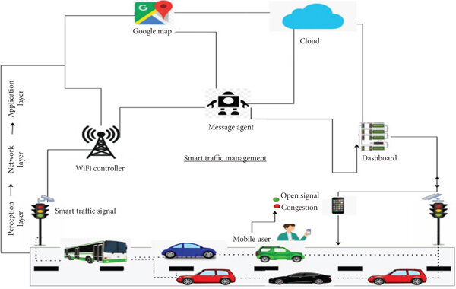

DEVELPOMENT OF APP:

Developing an app for traffic management and route recommendations can be very useful for commuters. Here are a few steps to get started:

1. Define the scope of your app: Determine what specific features you want to include in your app. Some possible features could be real-time traffic updates, route recommendations based on current traffic conditions, alternative route suggestions, and personalized preferences for users such as avoiding toll roads or highways.

2. Conduct market research: Look into existing traffic management and navigation apps to understand their features and identify any gaps that your app can fill. This will help you understand your target audience and their needs.

3. Create wireframes and design: Sketch out the user interface and design the app's features. Consider making the app user-friendly, with clear navigation and intuitive controls.

4. Develop the backend infrastructure: Build the necessary server infrastructure to handle real-time traffic data and store user preferences. This will require programming skills and knowledge of databases.

5. Implement real-time traffic updates: Integrate a reliable traffic data provider into your app to provide accurate and up-to-date information to users. Options include services like Google Maps API, HERE Traffic API, or TomTom Traffic API.

6. Develop route recommendation algorithms: Use algorithms to analyse real-time traffic data and suggest the most efficient routes based on user preferences. This may involve considering factors such as current traffic conditions, historical data, and user feedback.

7. Test and optimize: Thoroughly test your app to ensure it performs well under various scenarios and conditions. Gather feedback from beta testers and make necessary optimizations based on their input.

8. Launch and promote: Once your app is ready, launch it on relevant platforms such as the App Store and Google Play. Implement marketing strategies to promote your app and reach your target audience.

Remember, developing an app is a complex process that requires time and expertise. Consider seeking professional help or collaborating with experienced developers if needed.

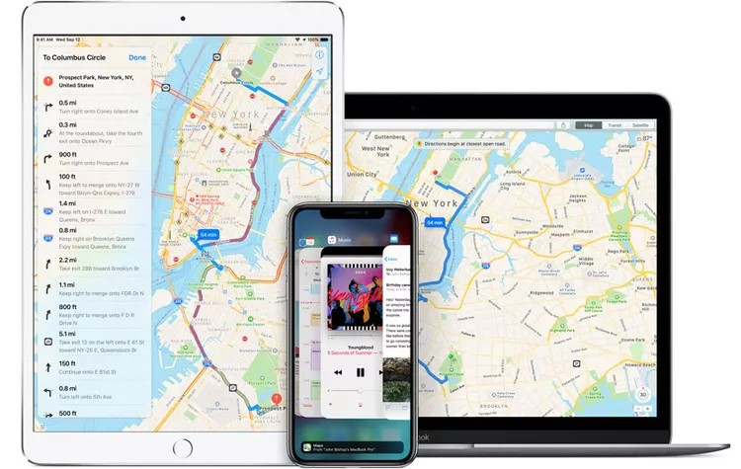

PROGRAM:(Using HTML, CSS, and JavaScript):

Here's a program using HTML, CSS, and JavaScript to create a simple app for traffic updates and route recommendations:

HTML CODE:

A program using html is used to create a display App just by running a html Program . here is a example of the app we create for a traffic updates and routes.

<!DOCTYPE html>

<html lang="en">

<head>

<meta charset="UTF-8">

<meta name="viewport" content="width=device-width, initial-scale=1.0">

<title>Traffic App</title>

<link rel="stylesheet" href="styles.css">

</head>

<body>

<div id="app">

<h1>Real-Time Traffic Updates</h1>

<p id="trafficData">Fetching traffic data...</p>

<label for="startLocation">Start Location:</label>

<input type="text" id="startLocation" placeholder="Enter start location">

<label for="endLocation">End Location:</label>

<input type="text" id="endLocation" placeholder="Enter end location">

<button id="routeBtn">Get Route Recommendations</button>

<div id="routeRecommendations"></div>

</div>

<iframe src="https://www.google.com/maps/embed?pb=!1m28!1m12!1m3!1d1997699.2574773899!2d77.29474156810653!3d12.060277246200265!2m3!1f0!2f0!3f0!3m2!1i1024!2i768!4f13.1!4m13!3e6!4m5!1s0x3a5265ea4f7d3361%3A0x6e61a70b6863d433!2schennai!3m2!1d13.082680199999999!2d80.27071839999999!4m5!1s0x3ba859af2f971cb5%3A0x2fc1c81e183ed282!2scoimbatore!3m2!1d11.0168445!2d76.9558321!5e0!3m2!1sen!2sin!4v1698151026534!5m2!1sen!2sin" width="600" height="450" style="border:0;" allowfullscreen="" loading="lazy" referrerpolicy="no-referrer-when-downgrade"></iframe>

<script src="app.js"></script>

</body>

</html>

CSS CODE:

Next we have to create a .css program using a name style.css by giving a font colour and margins to the display page we create here we have a css program which will be linked with the above html program to run and get a display app.

body {

font-family: Arial, sans-serif;

margin: 0;

padding: 0;

}

#app {

display: flex;

flex-direction: column;

align-items: center;

justify-content: center;

height: 100vh;

}

h1 {

margin-bottom: 20px;

}

button {

padding: 10px 20px;

border-radius: 5px;

background-color: #007bff;

color: #fff;

border: none;

cursor: pointer;}

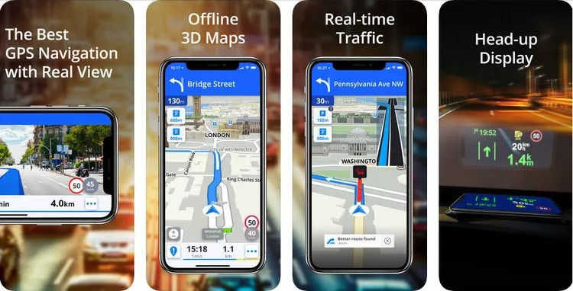

JAVA SCRIPT CODE:

Java script plays an important role in fetching the data from the recovered resource. Java script consists of fetching a data using start and end location. We can save this as app.js this also will be linked with the html program to proceed output.

document.addEventListener('DOMContentLoaded', () => {

const trafficDataElement = document.getElementById('trafficData');

const startLocationInput = document.getElementById('startLocation');

const endLocationInput = document.getElementById('endLocation');

const routeRecommendationsElement = document.getElementById('routeRecommendations');

const routeBtn = document.getElementById('routeBtn');

// Fetch traffic data from API

fetch('https://www.google.com/maps/embed?pb’)

.then(response => response.json())

.then(data => {

trafficDataElement.innerText = `Current Traffic: ${data.status}`;

})

.catch(error => {

trafficDataElement.innerText = 'Failed to fetch traffic data.';

});

routeBtn.addEventListener('click', () => {

const startLocation = startLocationInput.value;

const endLocation = endLocationInput.value;

if (startLocation && endLocation) {

// Logic to get route recommendations using a routing algorithm

const routeRecommendations = getRouteRecommendations(startLocation, endLocation);

// Display route recommendations on the app interface

routeRecommendationsElement.innerHTML = '';

for (const recommendation of routeRecommendations) {

const recommendationItem = document.createElement('p');

recommendationItem.innerText = recommendation;

routeRecommendationsElement.appendChild(recommendationItem);

}

} else {

Alert ('Please enter both start and end locations.');

}

});

// Function to get route recommendations using a routing algorithm

function getRouteRecommendations(startLocation, endLocation) {

// Implement your routing algorithm logic here

// Example:

const route1 = `Route 1: ${startLocation} - Waypoint 1 - Waypoint 2 - ${endLocation}`;

const route2 = `Route 2: ${startLocation} - Waypoint 3 - Waypoint 4 - ${endLocation}`;

return [route1, route2];

}

});

Here we can see a sample output of this traffic updates and route recommendation The data are fetched and shown using html code and after executing this run and get the required output.

OUTPUT:

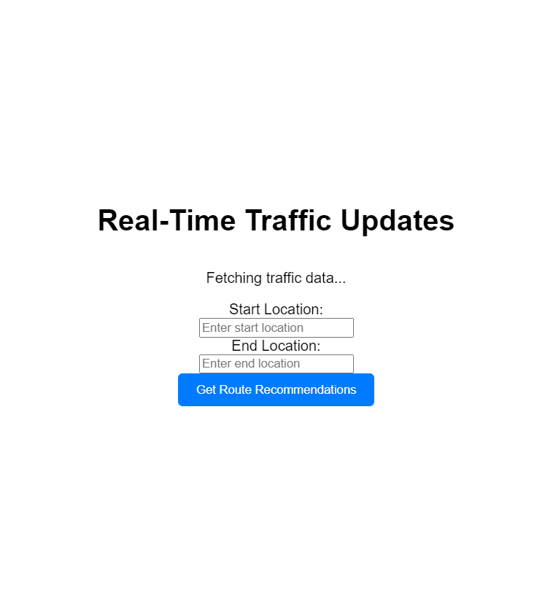

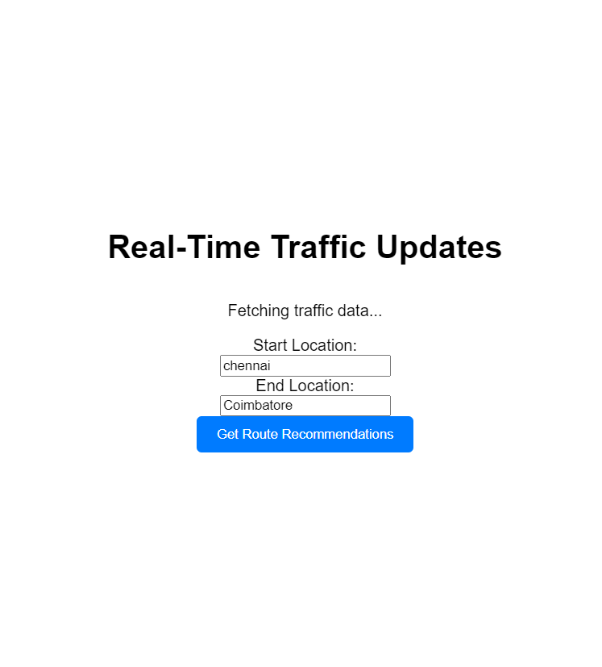

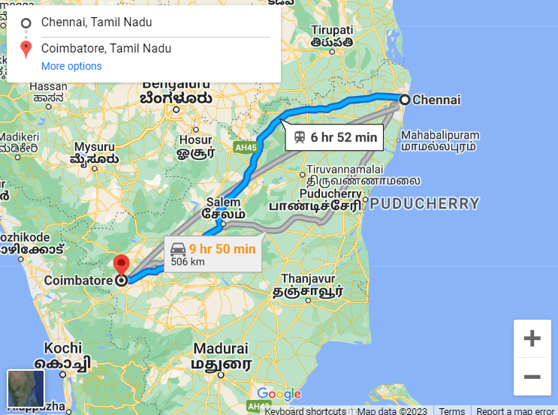

FEATURES:

1. Real-time traffic updates: The app fetches traffic data from an API and displays it to users.

2. Route recommendations: Users can enter their start and end locations, and the app suggests the best routes based on current traffic conditions.

3. User-friendly interface: The app provides a user-friendly interface for easy interaction and input of location details.

ADVANTAGES:

1. Time-saving: Users can avoid traffic congestion by following the recommended routes, saving time during their commute.

2. Reduce stress: Real-time traffic updates help users plan their journeys better, reducing stress

DISADVANTAGES:

1. Dependence on traffic data sources: The accuracy and reliability of the app heavily rely on the quality of the traffic data providers.

2. Connectivity requirements: The app requires a stable internet connection to retrieve real-time traffic data efficiently.

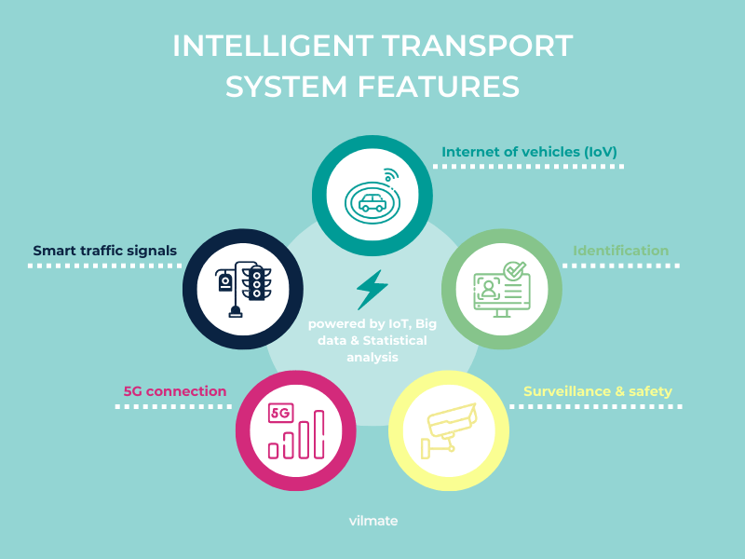

The provided program is a basic outline and not a complete solution. You will need to implement the necessary functionality in the JavaScript file (script.js) to retrieve traffic data, calculate routes, and display them on the map.